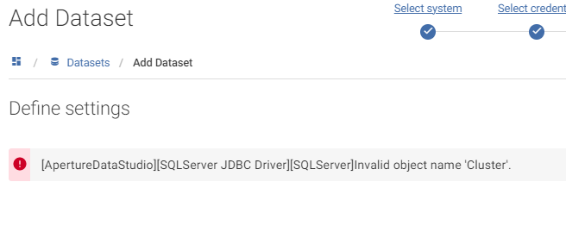

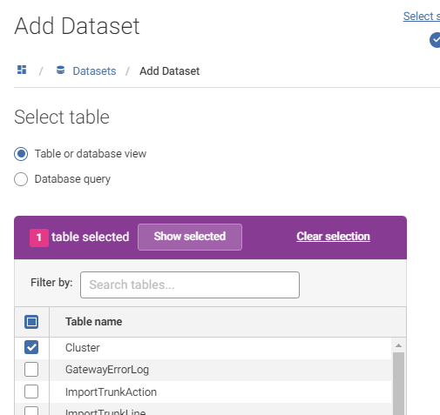

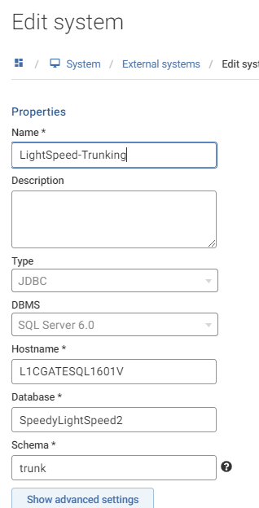

SELECT TOP (1000) [ID]
,[Name]
,[ManagerName]
,[Deleted]
,[IsMSC]
,[MSCID]
,[CreatedTS]
,[LastModifiedTS]
FROM [SpeedyLightSpeed2].[trunk].[Cluster]

