The Issue:
My workflow will create an export file indicating the main validation has started.
I want to run this for about 50 different validation files. I have made the source to be supplied at run time.
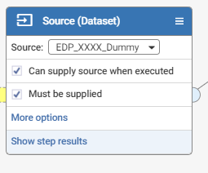

This is ok when run online
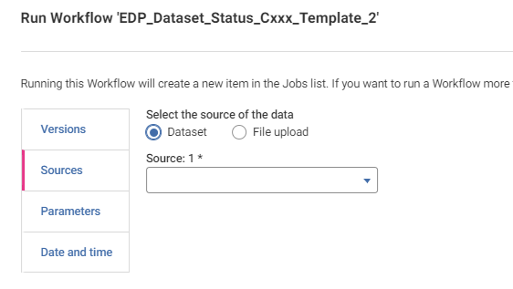

But no option in Notification to supply source:
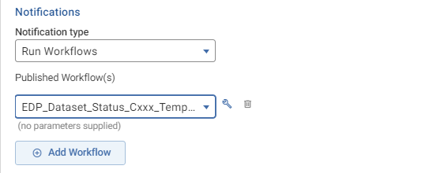

More Info:

The workflow just exports 1 line of the metadata of the dataset. This lets the submitter see that the main process has started and the file dropped in the datadropzone is picked up.

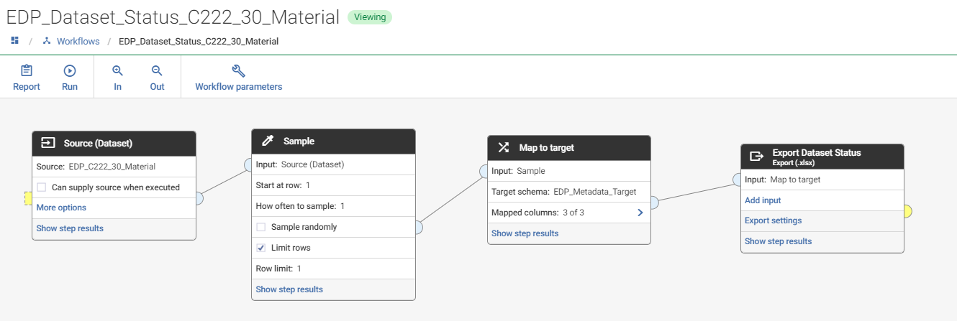

Currently I have to maintain 50 separate workflows to indicate that the main process started. If there was an option to provide the source in notification, I only need one workflow. Following is how I am defining it now:
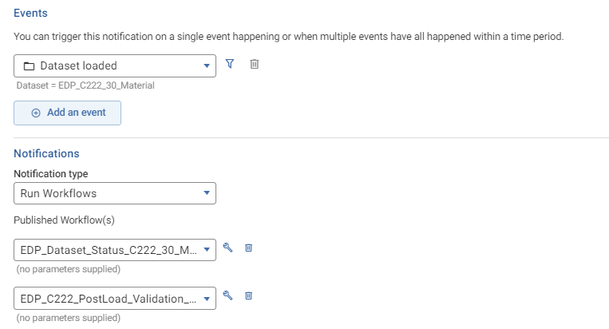

Example of the output of the starter workflow:
Metadata: Dataset | Metadata: Filename | Metadata: Timestamp
EDP_C222_30_Material | Postloadvalidation_C222_30_Reference material_Jan30b.txt | 30-Jan-2023 14:05:55

